Bear Path Compost, LLC

bearpath@comcast.net www.bearpathcompost.com

Mike Mahar Bill Obear Pete Mahar
413-386-4932 413-320-1262 413-824-2781

In 2015 the compost operation at Bear Path Farm was changed form a sole proprietorship to Bear Path Compost LLC with the addition of partners and future owners Mike and Pete Mahar. Bear Path Farm is 50 acres in size consisting of 11 acres in hay, 1 acre in peaches and apples, 2 acres in compost production and the balance being wetlands and productive woodlands. The farm officially became a commercial enterprise in 1996 with the startup of its compost operations.

2016 marks the 20th year of compost production for Bear Path Compost supplying high quality compost for multiple uses within the Pioneer Valley.
In 2015 Bear Path Farm produced and marketed approximately 1,600 cubic yards of compost that was sold to organic farms, nurseries, landscapers, garden designers and home gardeners. BPC compost is used as a soil amendment and as a top dressing for perennial gardens, fruit trees, shrubs and lawns. In 2016 BPC began offering compost/soil mixes in two blends 50/50 (1 part soil to one part compost) and 75/25 (3 parts soil to 1 part compost).

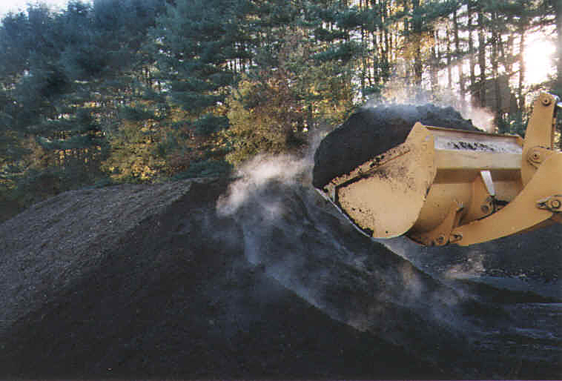
Steaming Compost During Turning

